HIBERNATE CRUD

CRUD(create,read/retrieve,update,delete)

1. Create a maven project from the eclipse IDE
2. If you couldn’t maven project click on the file and select other

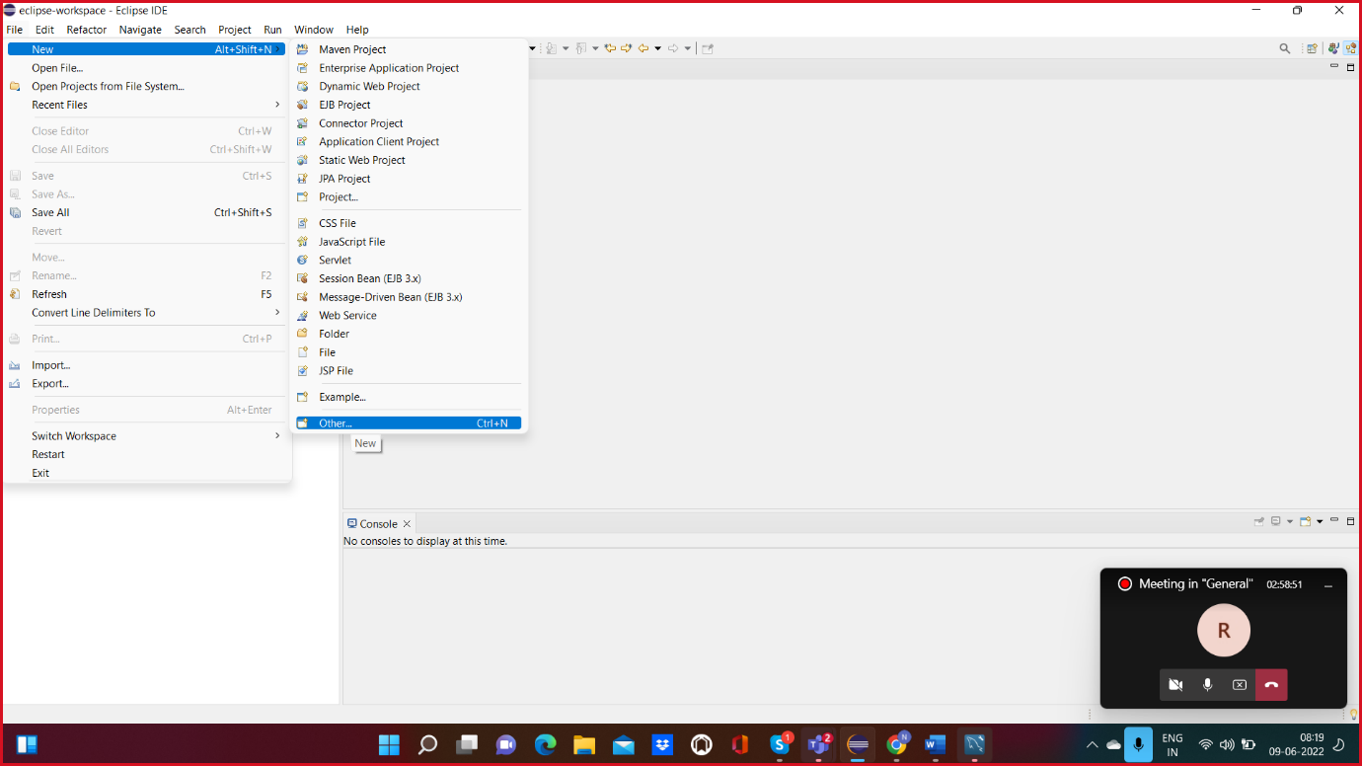

And then write maven project

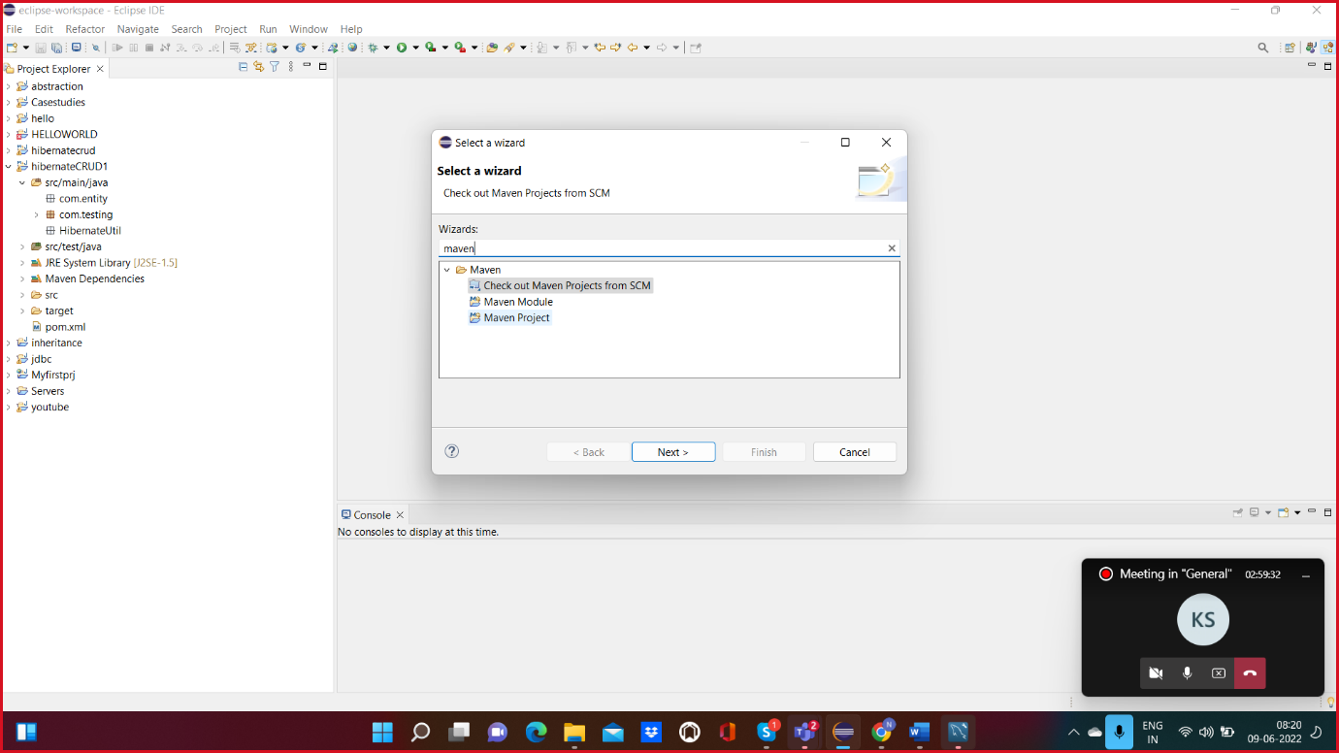

Click on next and then finish

For example if you couldn’t find the any plugins in the eclipse(Any version )IDE

1. Select help and click on it
2. Select install software option

And click on it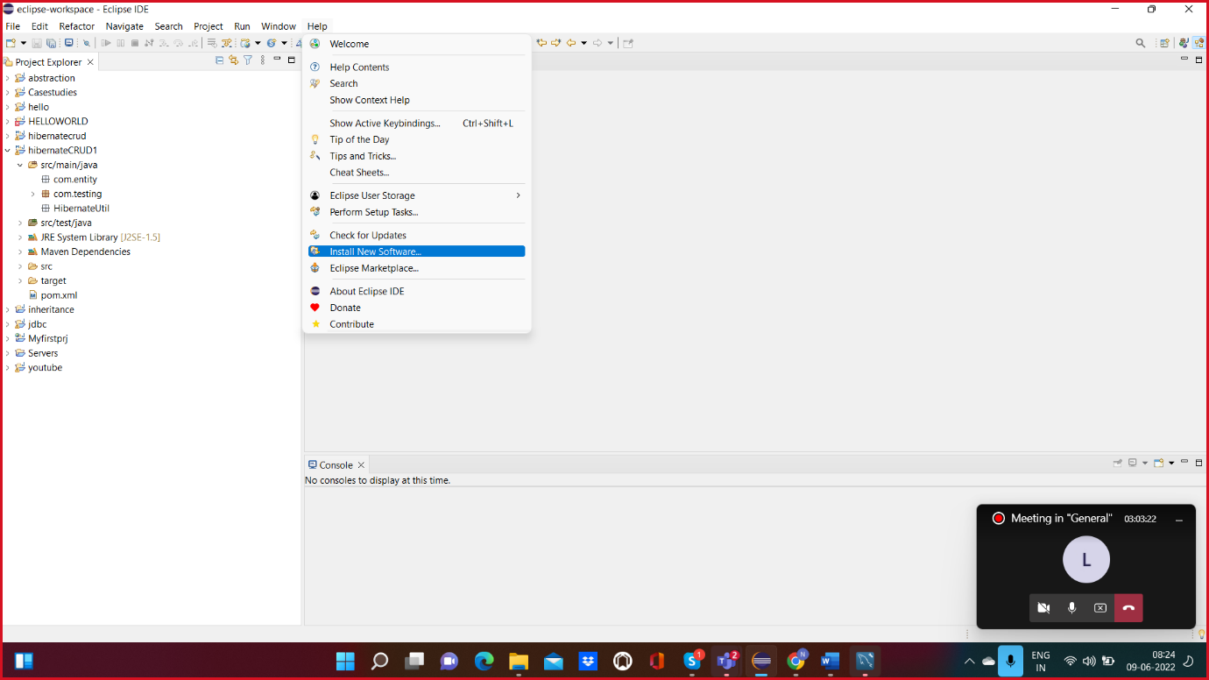

1. 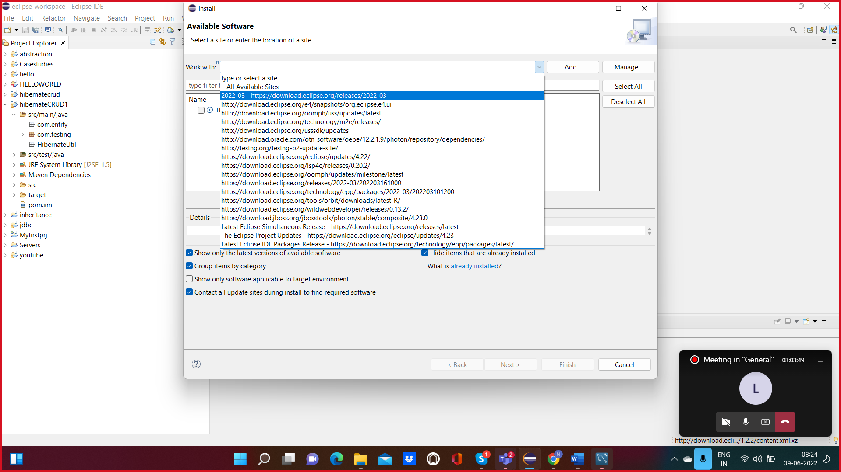

In the dropdown select for the release 2022

Then click on next and then click on finish.

MAVEN PROJECT

1. Create a project in the project explorer
2. Create 3 packages in the main src
3. Com.testing,com.entity,com.hibernatutil
4. Open the mysql workbench
5. Open the pom.xml
6. Creating a dependency jars in the pom.xml

Mysql jar

Hibernate jar

Lombok jar(optional)

1. 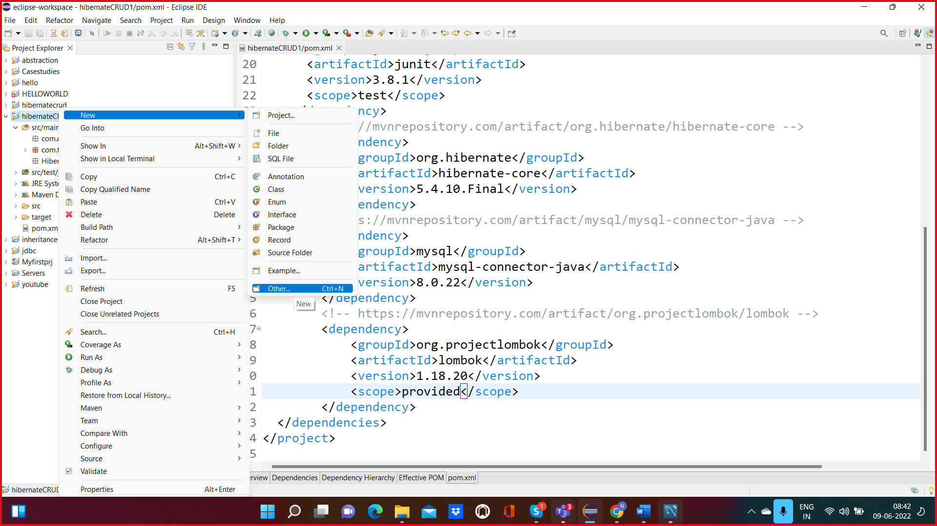

Right click on the project select other and choose xml file

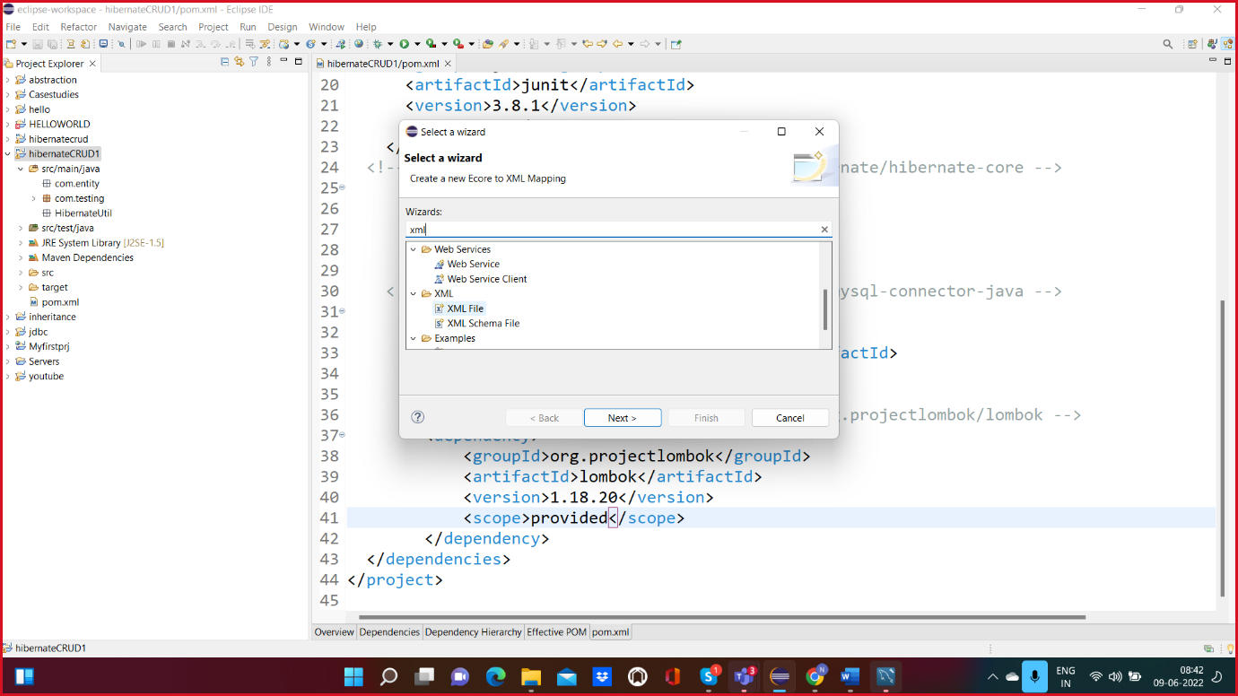

1. 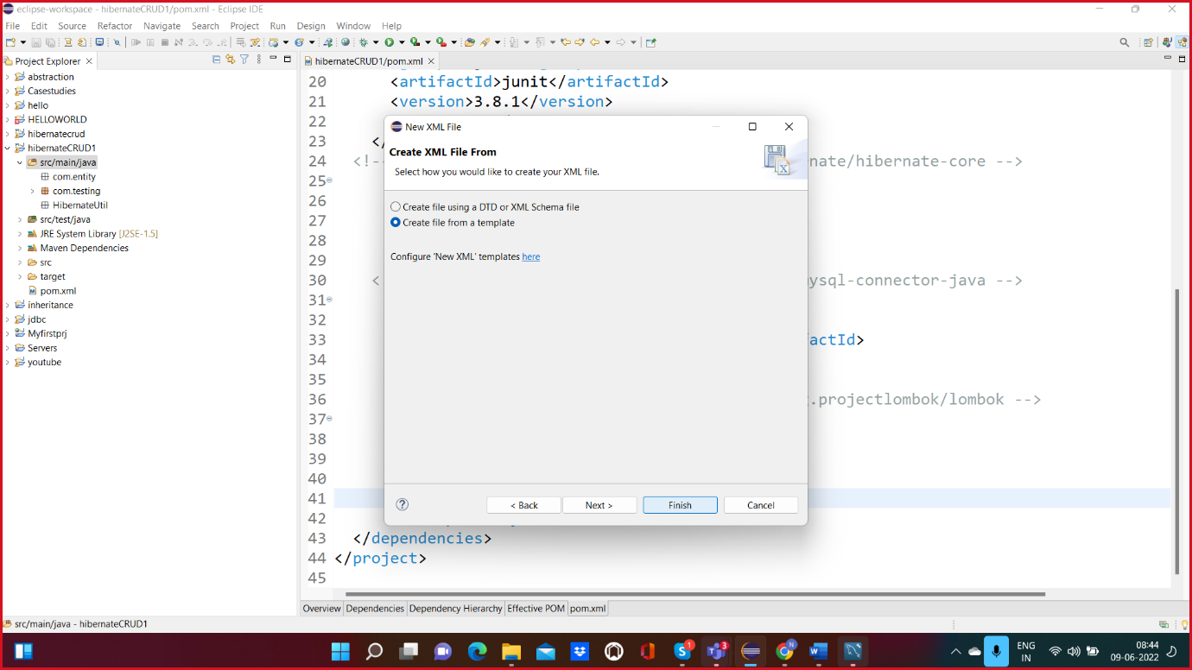
2. Click on the next and then finish.
3. Create hibernate.cfg.xml file
4. Add the configuration from the HIBERNATE DTD(present using 5.0 DTD)
5. Add the properties

//no need to add driver class property

// no need to add dialect MySQL8 property